LAB 07 ASSIGNMENT

QUESTION A (CODE)

#include <iostream>

using namespace std ;

int sub(int a,int b)

{

return a-b;

}

int mul(int a,int b)

{

return a*b;

}

double dev(int a,int b)

{

return a/double(b);

}

int rem(int a,int b)

{

return a%b;

}

int main ()

{

int x(12),y(5);

cout<<"Substraction = "<<sub(x,y)<<endl;

cout<<"Multiplication = "<<mul(x,y)<<endl;

cout<<"Division = "<<dev(x,y)<<endl;

cout<<"Reminder = "<<rem(x,y)<<endl;

return 0 ;

}

QUESTION A (OUTPUT)

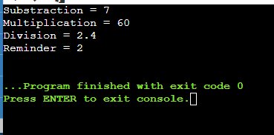

QUESTION B (CODE)

#include <iostream>

using namespace std ;

int square(int num)

{

return num*num;

}

int main ()

{

int a(7);

cout<<"The square of 7 is "<<square(a)<<endl;

system ("PAUSE") ;

return 0 ;

}

QUESTION B (OUTPUT)

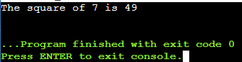

QUESTION C (CODE)

#include <iostream>

using namespace std ;

int compare(int a, int b)

{

if(a>b)

{

return a;

}

else

{

return b;

}

}

int main ()

{

int a(5),b(9);

cout<<"The greater value is "<<compare(a,b)<<endl;

system ("PAUSE") ;

return 0 ;

}

QUESTION C (OUTPUT)

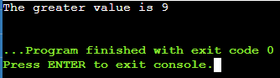

QUESTION D(CODE)

#include <iostream>

#include <string>

using namespace std ;

string value(int x)

{

if (x%2==0)

{

return "Even";

}

else

{

return "Odd";

}

}

int main ()

{

int x(7);

cout<<"The value is "<<value(x)<<endl;

system ("PAUSE") ;

return 0 ;

}

QUESTION D(OUTPUT)

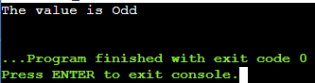

QUESTION E(CODE)

#include <iostream>

using namespace std ;

double per(double obt, int total)

{

return obt*100/total;

}

int main ()

{

double obt(57.8);

int total(60);

cout<<"Percantage= "<<per(obt,total)<<"%"<<endl;

   system ("PAUSE") ;

   return 0 ;

}

QUESTION E (OUTPUT)

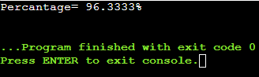

QUESTION F(CODE)

#include <iostream>

using namespace std;

void per(double obt, int total)

{

double percent;

 percent=obt*100/total;

cout<<"percentage="<<percent<<endl;

    if(percent>=80 && percent<=100)

    {

     cout<<"Grade is A\n";

    }

   else if(percent>=70 && percent<=79)

    {

     cout<<"Grade is B\n";

    }

    else if(percent>=60 && percent<=69)

    {

     cout<<"Grade is C\n";

    }

    else if(percent<60)

    {

     cout<<"Grade is F\n";

    }

    else

    {

        cout<<"Invalid input";

    }

    }

int main() {

int obt_marks,total_marks;

cout<< "write obtained marks"<<endl;

cin>>obt_marks;

cout<< "write total marks"<<endl;

cin>>total_marks;

 per(obt_marks,total_marks);

    return 0;

}

QUESTION F (OUTPUT)

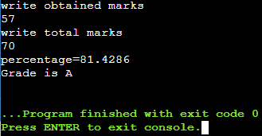

QUESTION G(CODE)

#include <iostream>

using namespace std;

bool value(int x)

{

    if(x%2==0)

    {

     cout<<"The number is even:\n";

  return true;

  }

   else

    {

        cout<<"The number is not even:\n";

        return false;

    }

    }

int main() {

int a;

cout<< "Enter the number to check if it is even or not"<<endl;

cin>>a;

value(a);

    return 0;

}

QUESTION G (OUTPUT)

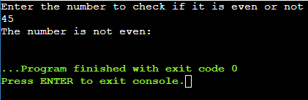

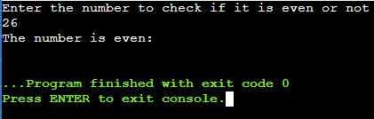

QUESTION H(CODE)

#include<iostream>

using namespace std;

int add(int);

int main()

{

int range;

cout<<"Enter the range up to which you want to find the sum:";

cin>>range;

cout<<"The sum of all "<<range<<" positve integer is "<<add(range);

return 0;

}

int add(int range){

int sum(0);

for(int i=1; i<=range; i++){

sum=sum+i;

}

return sum;

}

QUESTION H(OUTPUT)

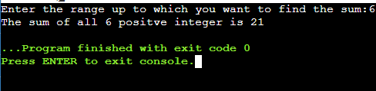

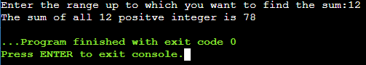

QUESTION I (CODE)

#include<iostream>

using namespace std;

void printTable(int);

void printTable (int,int);

int main()

{

int num,num1(0);

cout<<"Enter any number to print its table:";

cin>>num;

printTable(num);

printTable (num,num1);

return 0;

}

void printTable(int x){

for(int i=1; i<=10; i++){

cout<<x<<"×"<<i<<"="<<i*x;

cout<<endl;

}

}

void printTable(int x,int range){

cout<<"Enter the range up to which it prints table of a number:";

cin>>range;

for(int i=1; i<=range; i++){

cout<<x<<"×"<<i<<"="<<i*x;

cout<<endl;

}

}

QUESTION I (OUTPUT)

